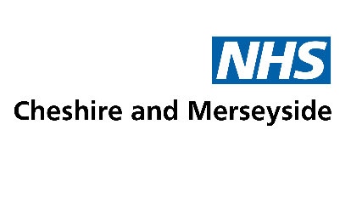

Communications Toolkit
Public consultation on proposed changes to fertility treatment policies in Cheshire and Merseyside
3 June – 15 July 2025

Introduction

NHS Cheshire and Merseyside Integrated Care Board (ICB) has launched a six-week public consultation on proposed changes to local fertility treatment policies, running from 3 June – 15 July 2025.
We want to encourage as many people as possible in our local communities to share their views with us during this period.
Included in this pack are resources for partner organisations to use to promote this opportunity via their own networks and channels.

Contact details
This toolkit has been compiled by NHS Cheshire and Merseyside’s communications and engagement team.

For further help, please email: engagement@cheshireandmerseyside.nhs.uk

What is happening?
Currently, there are ten NHS subfertility policies being used across Cheshire and Merseyside, which means that people have varying access to NHS funded fertility treatment, depending on where they live.
NHS Cheshire and Merseyside is proposing a new, single policy, which would mean that in the future everyone would get consistent access to this treatment in our area.
The new policy would include a number of changes that would remove variation, and ensure local practice is in line with national guidance, but we are also proposing to make some changes for financial reasons.

How to take part
People are being invited to download an information booklet summarising the key changes being proposed, and complete a short questionnaire to share their views on the NHS Cheshire and Merseyside website here:
https://www.cheshireandmerseyside.nhs.uk/get-involved/current-consultations-and-engagements/share-your-views-on-proposed-changes-to-fertility-treatment-policies-in-cheshire-and-merseyside/

Accessibility

An easy read version of the summary booklet is available at: AVAILABLE SOON

Anyone who would like to request some help to complete the questionnaire, or to request a printed version or an alternative format or language, can do so by contacting:

Phone: 0151 295 3052

Email: engagement@cheshireandmerseyside.nhs.uk

Post: Engagement Team, NHS Cheshire & Merseyside, No 1 Lakeside, 920 Centre Park Square, Warrington, WA1 1QY
Community groups or networks who would like NHS Cheshire and Merseyside to attend a meeting or event to talk about the proposal can email to request this via: engagement@cheshireandmerseyside.nhs.uk
Full Media Release – for use on websites

Public asked for views on proposed changes to fertility treatment policies
NHS Cheshire and Merseyside Integrated Care Board (ICB) has launched a six-week public consultation on proposed changes to local fertility treatment policies, running from 3 June – 15 July 2025.
Currently, there are ten separate policies for Cheshire and Merseyside, which means that eligible people have varying access to NHS-funded fertility treatment, depending on where they live.
NHS Cheshire and Merseyside is proposing to replace these policies with a new, single policy. This would mean that in the future, people across Cheshire and Merseyside would get the same access to NHS fertility treatment.
As part of the policy, it is proposed that one cycle of in vitro fertilisation (IVF) is funded for those who are eligible. Currently, between one and three cycles are provided on the NHS, depending on which part of Cheshire and Merseyside people live in.
At the moment, the local NHS spends over £5 million on IVF treatments every year, and it is estimated that moving to offering one IVF cycle would save around £1.3 million annually.
It would also mean that Cheshire and Merseyside was in line with the majority of other areas in England – 66% of ICBs only fund one IVF cycle.
A number of other changes are also being proposed within the new policy, to help standardise some eligibility criteria, and update the local policy to reflect national clinical guidance.
This includes proposed changes to eligibility based on BMI (body mass index), smoking status, age, the definition of childlessness, and changes to the requirement for IUI (intra uterine insemination) before IVF treatment in some areas.
A six-week public consultation is being held between 3 June to 15 July 2025, giving people the opportunity to learn more about the proposed changes and share their views.

People can download an information booklet and complete a short questionnaire on the NHS Cheshire and Merseyside website at:
https://www.cheshireandmerseyside.nhs.uk/get-involved/current-consultations-and-engagements/share-your-views-on-proposed-changes-to-fertility-treatment-policies-in-cheshire-and-merseyside/
Anyone who would like to request some help to complete the questionnaire, or to request a printed version or an alternative format or language, can do so by phoning: 0151 295 3052 or emailing: engagement@cheshireandmerseyside.nhs.uk

Dr Fiona Lemmens, Deputy Medical Director for NHS Cheshire and Merseyside said:

“The NHS is currently facing serious financial challenges, and this means we’re having to make some very difficult decisions about how we spend our local health budget.

“We know that access to fertility treatment is a sensitive issue, but we believe that moving to a single IVF cycle is the best way to ensure that we can continue to provide this treatment for our population.

“We have drafted the new policy based on what we feel balances local need and affordability, but before we finalise it, we are committed to listening to feedback from our communities.

“We want to encourage people to share their views by taking part in the public consultation, to tell us how these changes might affect them, and what they think might help to minimise any negative impact.”
Once the consultation closes, the findings will be analysed and compiled into a report. This will be presented to the Board of NHS Cheshire and Merseyside for a final decision, likely in late summer or early autumn 2025.
Further information will be shared about the outcome, and what this means for people who use fertility services. Until then, the existing policies will still apply and people can continue to access fertility treatment just as they do now.
To learn more and take part in the online questionnaire, go to:
https://www.cheshireandmerseyside.nhs.uk/get-involved/current-consultations-and-engagements/share-your-views-on-proposed-changes-to-fertility-treatment-policies-in-cheshire-and-merseyside/

ENDS
Shorter version of copy – for internal / external use
Share your views on proposed changes to fertility treatment policies
NHS Cheshire and Merseyside Integrated Care Board (ICB) has launched a six-week public consultation on proposed changes to local fertility treatment policies, running from 3 June – 15 July 2025.
Currently, there are ten separate policies for Cheshire and Merseyside, which means that eligible people have varying access to NHS-funded fertility treatment, depending on where they live.
NHS Cheshire and Merseyside is proposing to replace these policies with a new, single policy. This would mean that in the future, people across Cheshire and Merseyside would get the same access to NHS fertility treatment.
As part of the policy, it is proposed that one cycle of in vitro fertilisation (IVF) is funded for those who are eligible. Currently, between one and three cycles are provided on the NHS, depending on which part of Cheshire and Merseyside people live in.
The local NHS spends over £5 million on IVF treatments every year, and it is estimated that moving to offering one IVF cycle would save around £1.3 million annually.
It would also mean that Cheshire and Merseyside was in line with the majority of other areas in England – 66% of ICBs only fund one IVF cycle.
A number of other changes are also being proposed within the new policy, to help standardise some eligibility criteria, and update the local policy to reflect national clinical guidance.
This includes proposed changes to eligibility based on BMI (body mass index), smoking status, age, the definition of childlessness, and changes to the requirement for IUI (intra uterine insemination) before IVF treatment.
People can download an information booklet out find out more, and share their views by completing a short questionnaire on the NHS Cheshire and Merseyside website at:
https://www.cheshireandmerseyside.nhs.uk/get-involved/current-consultations-and-engagements/share-your-views-on-proposed-changes-to-fertility-treatment-policies-in-cheshire-and-merseyside/
Anyone who would like to request some help to complete the questionnaire, or to request a printed version or an alternative format or language, can do so by phoning: 0151 295 3052 or emailing: engagement@cheshireandmerseyside.nhs.uk
Further information will be shared about the outcome, and what this means for people who use fertility services after the consultation closes. Until then, people can continue to access fertility treatment just as they do now.
ENDS

Social media copy

Below are some examples of messages you can share on social media, as well as some graphic options. Please link to or shorten the URLs.

Theme | Message
Launch message | NHS Cheshire and Merseyside is holding a public consultation on some proposed changes to NHS funded fertility treatment – running from 3 June to 15 July 2025.  You can find out more & share your views at: https://www.cheshireandmerseyside.nhs.uk/get-involved/current-consultations-and-engagements/share-your-views-on-proposed-changes-to-fertility-treatment-policies-in-cheshire-and-merseyside/
Signpost to take part in the questionnaire | Have you shared your views on proposed changes to fertility treatment policies in Cheshire and Merseyside yet?  You can share your views by completing a short questionnaire at: https://www.cheshireandmerseyside.nhs.uk/get-involved/current-consultations-and-engagements/share-your-views-on-proposed-changes-to-fertility-treatment-policies-in-cheshire-and-merseyside/
Final reminders | It’s still not too late to share your views on proposed changes to fertility treatment policies in Cheshire and Merseyside – the consultation closes on 15 July.  Find out more & share your views by completing a short questionnaire at: https://www.cheshireandmerseyside.nhs.uk/get-involved/current-consultations-and-engagements/share-your-views-on-proposed-changes-to-fertility-treatment-policies-in-cheshire-and-merseyside/

Social media graphics – click and save on the images below

Option 1: Gif (animated square)

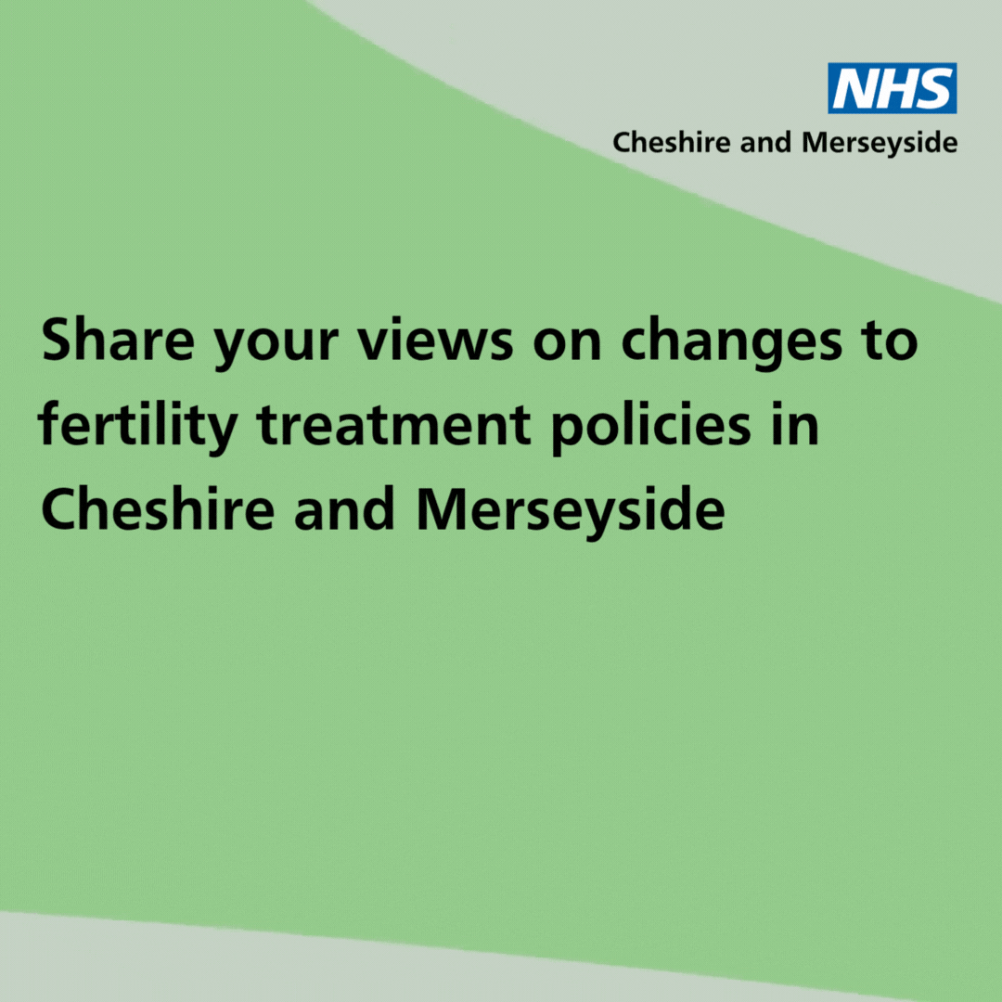

Option 2: PNG (static square)

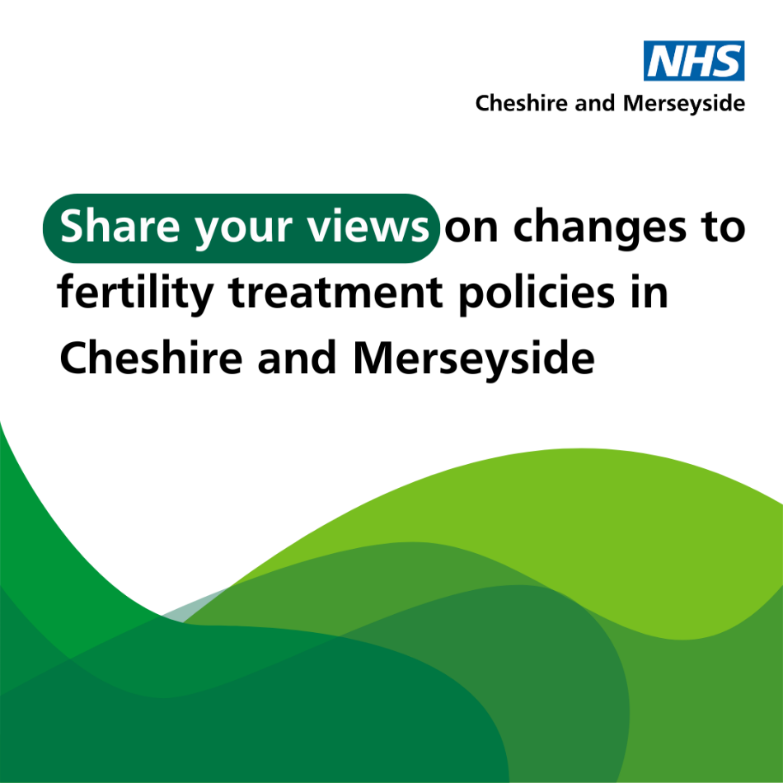

Further supporting information

- View the ten existing local subfertility policies at: https://www.cheshireandmerseyside.nhs.uk/your-health/clinical-policies/ - simply scroll to the map at the end of the page and click on the area you want to see the policy for.

- Read the new (draft) fertility policy in full at: draft-proposed-policy-nhs-funded-treatment-for-subfertility.docx

